CountBinaryTree

Y

X

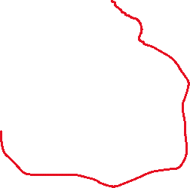

Total sum of left sub tree=x

Total sum of left sub tree=y

So the sum of all nodes = x+y+1

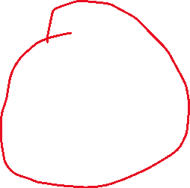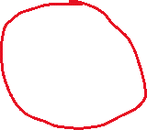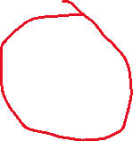

Height of tree

To find the the Height of a tree first find the height of left subtree and then height of right subtree and compare whose height is larger that is the height of the tree..

The Height of Tree is 4

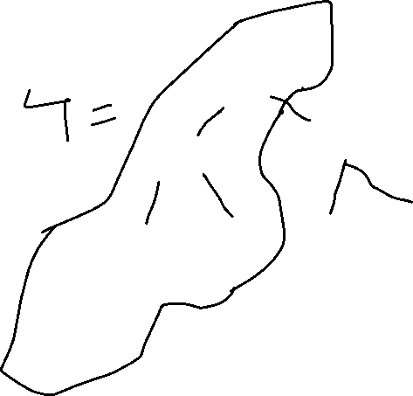

Diameter of a Tree

The diameter/width of a tree is defined as the number of nodes on the longest path between two end nodes.

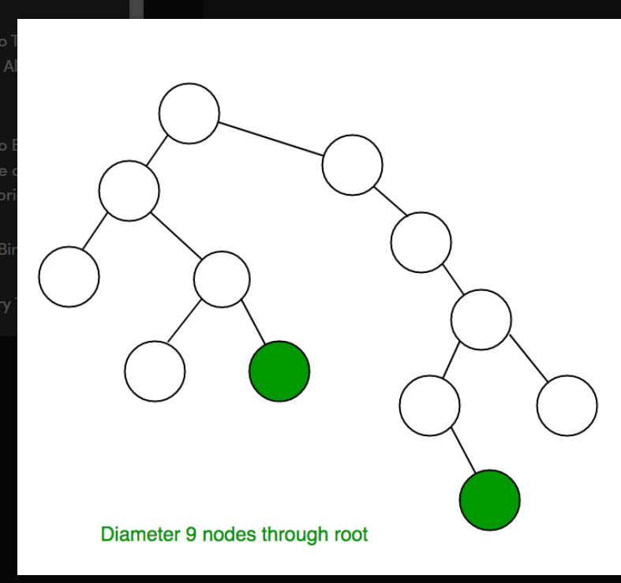

Case 1 Case2

There are two Case will Occur first is Case 1 In which a total diameter calculate through the root and Case2 the total diameter calculate NOT through the root

Heap

*A Heap is a special Tree-based data structure in which the tree is a complete binary tree.*

Heap is a complete binary tree + added Property

**There are two types of heap**:

1. Max heap
2. Min Heap

**Maxheap**: when the parent value is greater then its child value then it is known a MaxHeap (H>L,R).

Root to leap path is independent from each other

**Minheap:** when the Parent value is smaller then its child value and their sub parent are smaller then their child then it is known as min heap.Top of the tree have the lowest value of the tree(H<L,R)

**Operations on Heap:**

**Insertion:** We can add element from the bottom of the tree and then make it a max heap by swapping its positions

**Deletion:** Deleting top element of the heap or the highest priority element and then organizing the heap and returning element with the time complexity O(logN)

**Peek:** To check or find the most prior element in the heap **(Max or Min element for the max and min heap)** that means of the heap is the max heap then it will peek into the maximum value of the tree and if the tree is min heap then it will peek into the minimum value of the tree

**Heapify:** The process of creating a heap from the Array